**Issue 7**: Payment amount is not editable, if this is part of bill payment workflow

**Description**: If this screen is part of an online shopping site, then the payment amount (30.00) being not able to edit makes sense. But, if this screen is part of a bill payment workflow (such as paying mobile bill/electricity bill…) then there should be an option to edit the amount of payment.

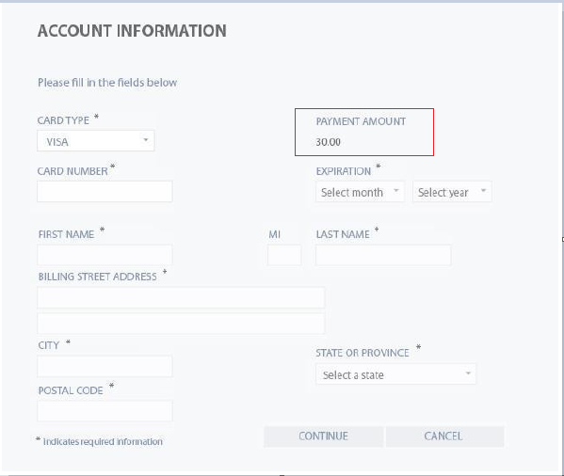

**Expected Behavior**: If this screen is part of a bill payment workflow (such as paying mobile bill/electricity bill…) then there should be an option to edit the amount of payment.

**Severity**: Major